**GRASP PATTERNS**

Grasp Patterns were implemented in this project and two of the examples are given below :

1.

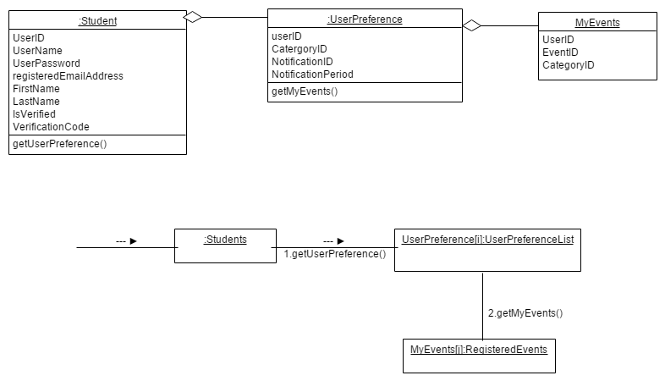

**2.**

